TNTAP INSTRUCTIONS
Go to tntap.tn.gov/eservices
Scroll below the login box and select the option, don’t have an account create one
Fill out all requested information. When asked to select the ID Type, you will select either Social Security Number, or Federal ID Number.
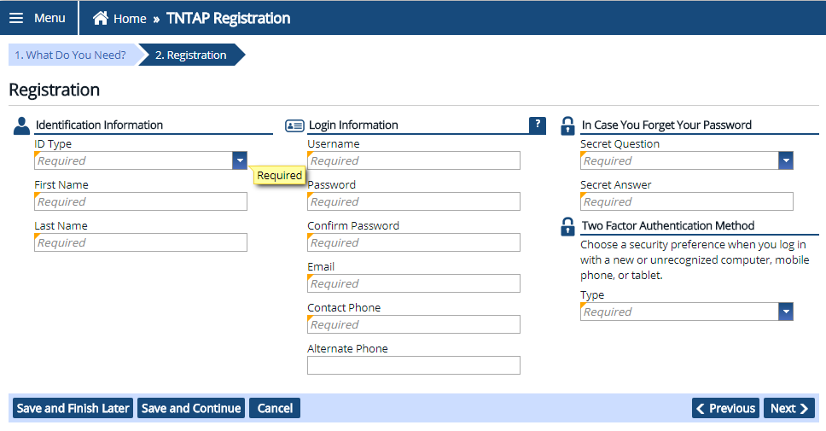
Continue entering all required information for steps 1-3. When you get to step 4, under the first section you will select yes, I have my account details.
Under the second section Account Summary, you will select Sales and Use Tax as the Account Type, and will enter your Sales Tax ID as well as your zip code. Within the final section, How would you like to verify your account, you will select the Enter Letter ID option, enter the Letter ID, and hit next. 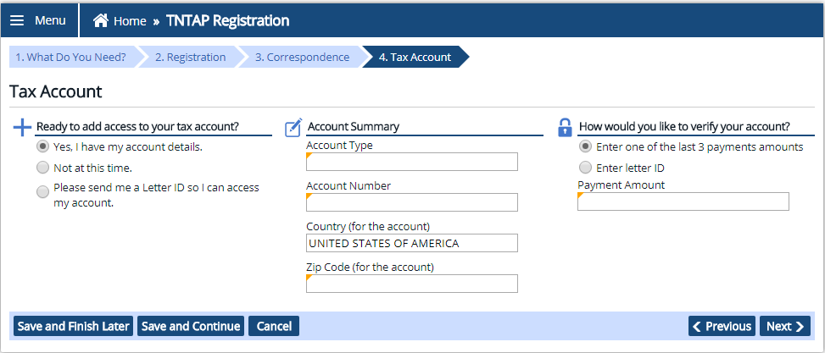

Next it will ask you to confirm your registration information. You may review your information and then will need to submit the account set up request.
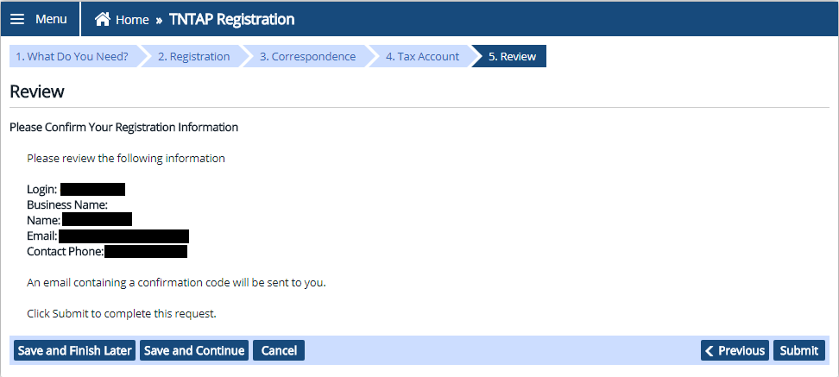
Once you submit the request you will receive confirmation of your account set up being complete, and will also receive confirmation by email or text, depending on what you selected during your account set up. Be sure to select OK to complete the request or you may print the confirmation.
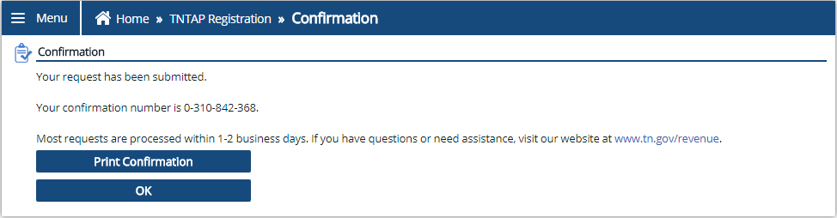

You will be taken back to the TNTAP home screen and will need to login with the username and password you have set up. When logging in you will be required to enter a confirmation code. You will select, Send Authentication. It will send the confirmation code to either your email or by text, depending on what you selected previously during your account set up process. You will then enter the code, and select logon.
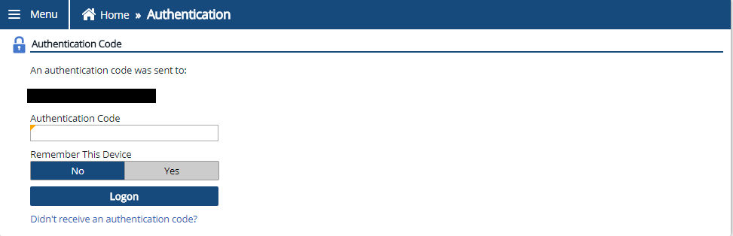

Once you are on your account home screen you go below the section labeled I Want To, and will select the option Manage Accounts.
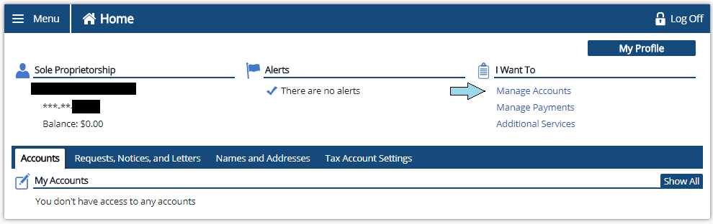
Then you will select the option, Gain Access to a Tax Account.
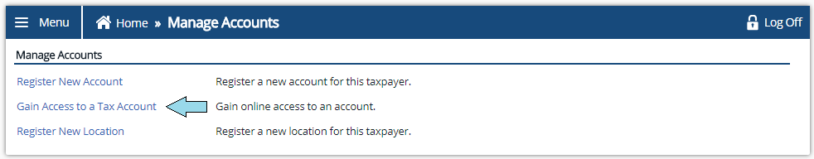
As requested previously- you will fill out required information. You will select Sales and Use Tax as the Account Type and enter your Sales Tax Number (Account ID), and zip code. When asked how you would like to verify your account select Letter ID and enter the Letter ID as before. Select next and then submit the request. Be sure to either select OK or Print Confirmation.
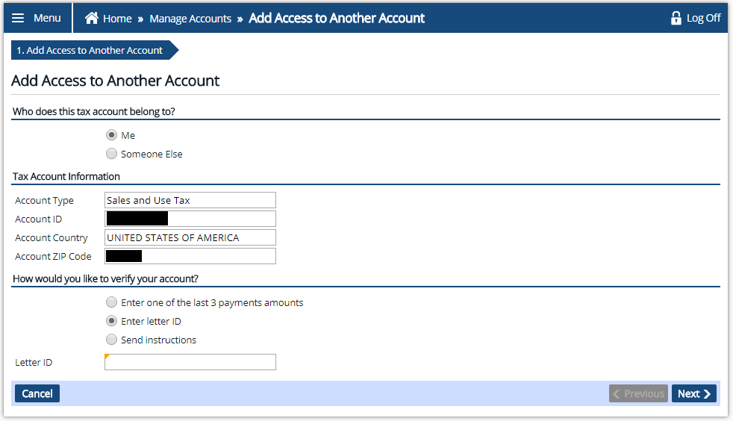
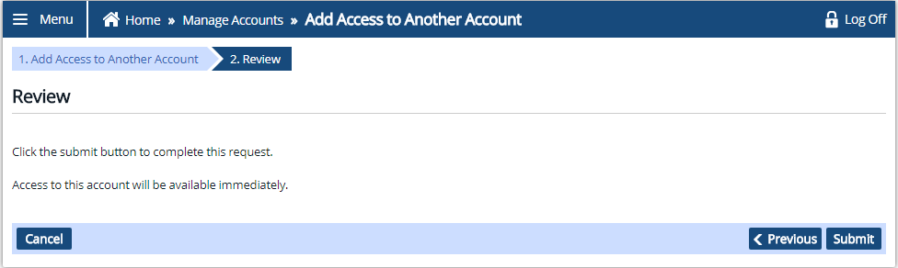
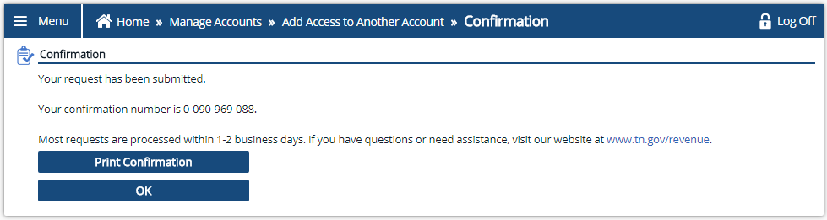
When you are back on your account home screen you will go to the very bottom under the section labeled My Account. You will see a notification for Sales and Use Tax with a red exclamation mark, and will need to select this notification.
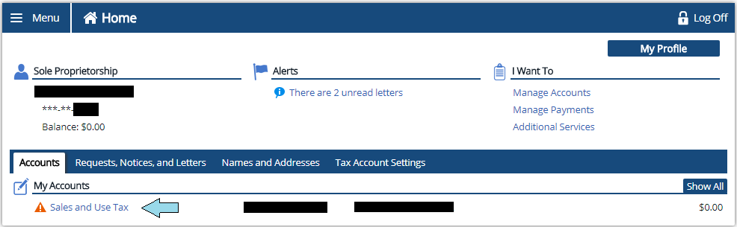
On the next page you will select the notification under the section labeled Account Alerts.
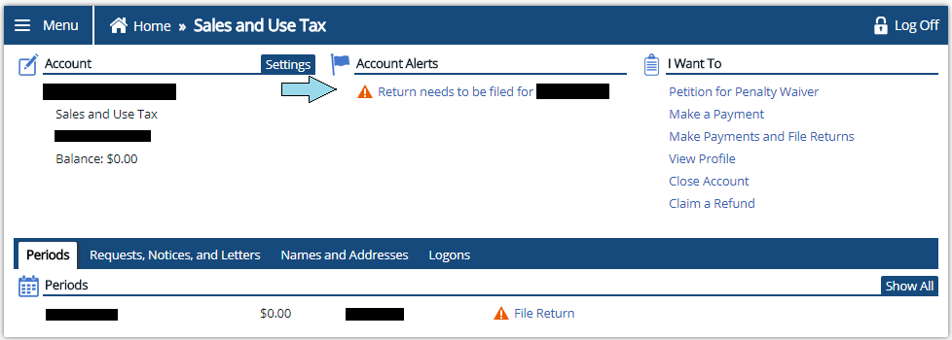
It will then ask if you will be submitting a file provided by your software vendor. After making your selection it will then request you select a location in which you would like to file for. Select a location and hit next to move forward.
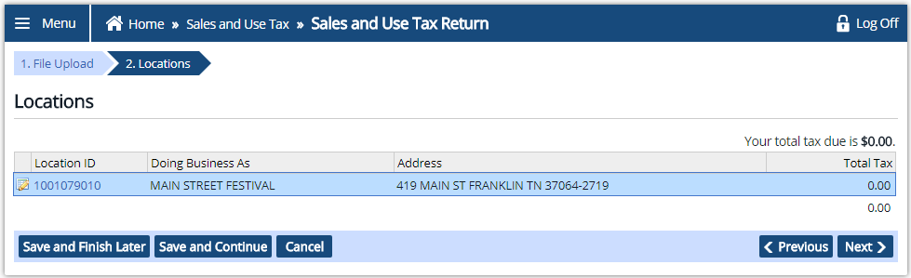

You will then be asked if you have any sales to report for the period in which you are trying to file for. You will make your selection, hit okay, and it will take you into the return.
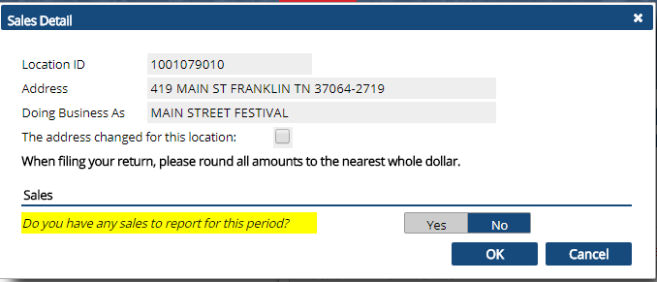
You will fill out the return and ensure that you have submitted and fully processed the return. Once the return has been submitted you will then return to your home screen, and will see the tax due for the return. Select the amount shown and it will then take you to where you can select a payment method, and process payment.
You will receive a confirmation of the return being processed along with confirmation of payment.

